**DATA SERIALIZATION AND EXCHANGE OVER NETWORK**

**1. Refer “little_big_endian_converter.c”. Implement the below functions and test.**

**int swap_int32(int val); // swap the bytes in input and convert from little to big endian**

**void showbytes(char *value, int n); // display n bytes starting from given address)**

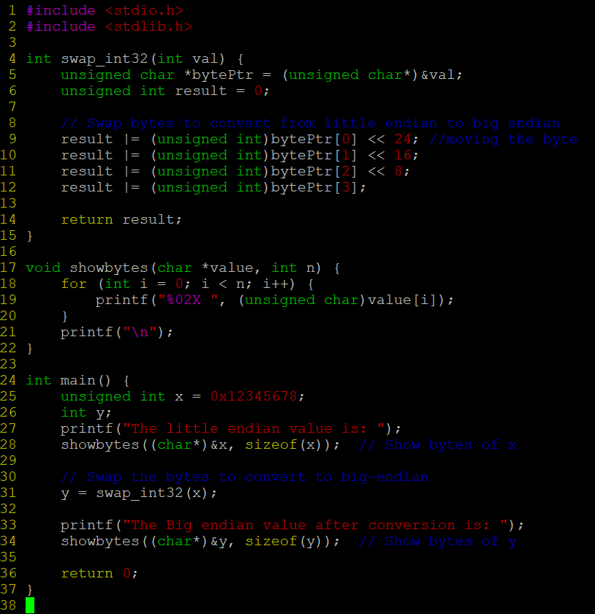

**OUTPUT:**

**2. Write a program to detect and display the endianness of the processor.**

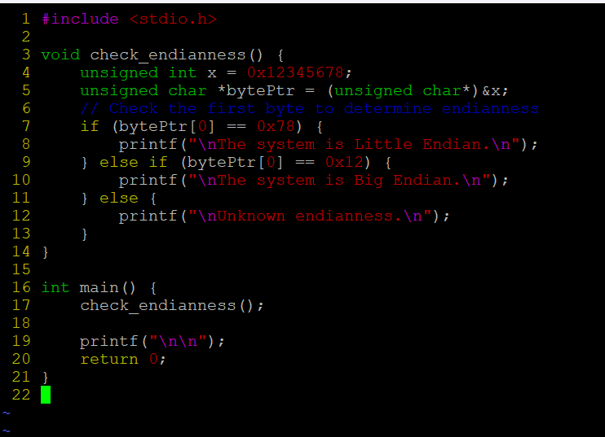

**OUTPUT:**

